SQLServer lab
Note: Use ITI DB
- Create a scalar function that takes date and returns Month name of that date.

- Create a multi-statements table-valued function that takes 2 integers and returns the values between them.

- Create inline function that takes Student No and returns Department Name with Student full name.

- Create a scalar function that takes Student ID and returns a message to user
- If first name and Last name are null then display 'First name & last name are null'
- If First name is null then display 'first name is null'
- If Last name is null then display 'last name is null'
- Else display 'First name & last name are not null'

- Create inline function that takes integer which represents manager ID and displays department name, Manager Name and hiring date
- Create multi-statements table-valued function that takes a string
If string='first name' returns student first name
If string='last name' returns student last name
If string='full name' returns Full Name from student table
Note: Use “ISNULL” function
- Write a query that returns the Student No and Student first name without the last char
- Wirte query to delete all grades for the students Located in SD Department
- Using Merge statement between the following two tables [User ID, Transaction Amount]

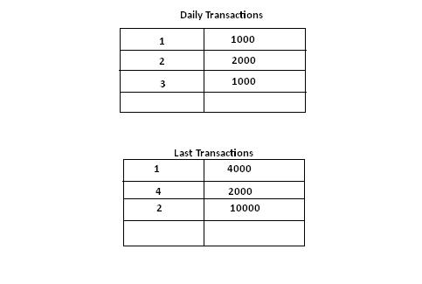

- Try to Create Login Named(ITIStud) who can access Only student and Course tablesfrom ITI DB then allow him to select and insert data into tables and deny Delete and update

